## EPIC Production Hyperdrive Shortcut Installation – IT Guide

These steps will install the desktop shortcut labeled "EPIC Production Hyperdrive" (shown on the right).

Once installed, the user can simply click this shortcut to launch EPIC directly—no web browser required.

## Pre-Install Checklist.

* Instruct the user to **save their work** and **close all applications**. This will speed up the process and ensure files are saved in case a reboot is required.
* Ensure any EPIC programs in the Web Browser.
* **Check for peripherals:**
  + If the computer has a **desktop scanner** or **a credit card device (Only these affected: Ingenico/Verifone)**, **additional steps are required**.
* A **reboot is not typically needed** unless an error occurs.

## Timing Expectations:

* The new shortcut will typically appear on the user's desktop in **~25 minutes** on a wired connection.
* On **Wi-Fi**, it may take up to **45 minutes**.
* The installation steps themselves should take **approximately 15 minutes** or less to complete.
* **Note:** The Technician may disconnect from the session before the shortcut is created.

## Do NOT install on computers with Imprivata.

FYI, Imprivata creates these folders. If you see these folders and Imprivata is active, do not proceed with these instructions.

program files (x86)\Epic\satellite\114.0.1.0

program files (x86)\Epic\satellite\114.0.3.0

**Below is an Imprivata Login Screen**

## Steps to install the EPIC Desktop Shortcut

### Log in as Administrator

Log in as an Administrator.

### Run Install Script: Navigate to

\\FS1.mnhc.local\Ochin\satellite_install  
Right-click on **Satellite Install.bat** and select 'Run as Administrator'. You May see an error that “UNC paths are not supported”. That is ok, as long as the file directry is created in the next step.

### Verify that the Directory is Created.

C:\Program Files (x86)\Epic\satellite\103.0.40  
If missing, rerun the script. Reboot if needed.

### Force Update Satellite.exe via Command Prompt

Open an Elevated Command Prompt and Navigate to:  
C:\Program Files (x86)\Epic\satellite\103.0.40  
Enter: Satellite.exe /f

This command will create a directory and update satellite.exe  
C:\Program Files (x86)\Epic\satellite\114.0.5.0

Wait approximately 1-2 minutes for the update to complete, and then return to the DOS prompt.

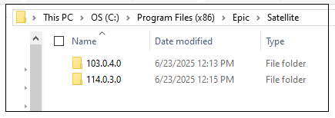

**Done - Reboot Computer is NOT Needed**

• The new desktop shortcut will typically appear in ~25 minutes on a wired connection.

• On Wi-Fi, it may take up to 45 minutes.

• **If 1 hour has passed and the shortcut is not visible, I suggest a reboot of the computer.**

## Post-Install Checklist

### Desktop Scanner Connected? Follow These Steps

- The Xerox Portable Desktop Scanner orFujitsu-Ricoh scanners, will not work with the new shortcut. Apply the fix below.

### Copy Folder, Execute a Script to Fix

Navigate to:

\\fs1.mnhc.local\Ochin\Satellite_Install - Peripheral Files\satellite_install - Desktop Scanner Fix

I suggest copying the entire "**Local Hyperdrive - OnBase Integration for Epic Install"** **folder** to the user's computer. The folder is large and will take about 5-7 minutes to copy, depending on bandwidth.

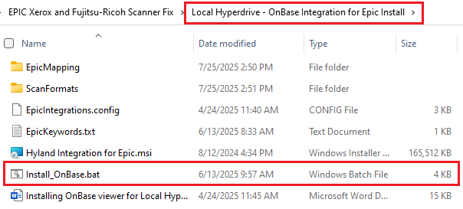

* Right-click **Install_OnBase.bat** and Run as Administrator.
* This process takes about 2 to 3 minutes. Verify that the installation was successful.
* You have the user launch EPIC from the desktop shortcut and log in to test out a scan.
* If successful, you can stop. If the error returns (See image below for details), then reboot is required.

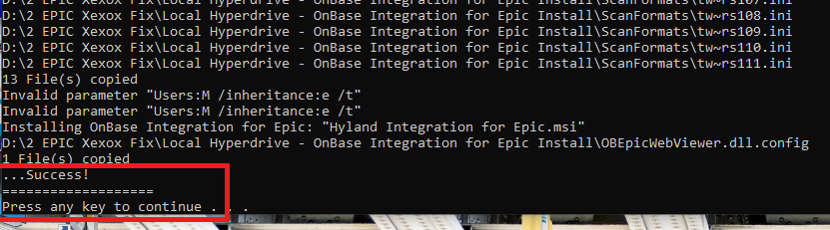

### Ingenico/Verifone Credit Card Device Connected. Reboot Not required

The credit card device will be disabled if this fix is not applied. These files are large and may take some time to copy over the network. Please close any programs on the user's computer to regain resources.

### Navigate to:

\\fs1.mnhc.local\Ochin\Satellite_Install - Peripheral Files\satellite_install - Ingenico-Verifone Fix

* Open the file "**Instructions-Credit Card Integration Update for Local Hyperdrive.pdf** and follow the steps.

### Dragon Voice Transcription App Installed?

Send to Greg Tremo

### If You See This Scanner Error: Run the above script to fix scanners.

### 